**Phase 3: Data Modeling & Relationships**

**1.Standard & Custom Objects**

* **Account** → Businesses or Customers (B2B vs B2C).
* **Contact** → Customer details.
* **Order** → Customer orders.
* **Product** → Items for sale.
* **Case** → Support tickets/complaints.
* **Campaign** → Marketing campaigns.
* Custom Objects
* **Wishlist**

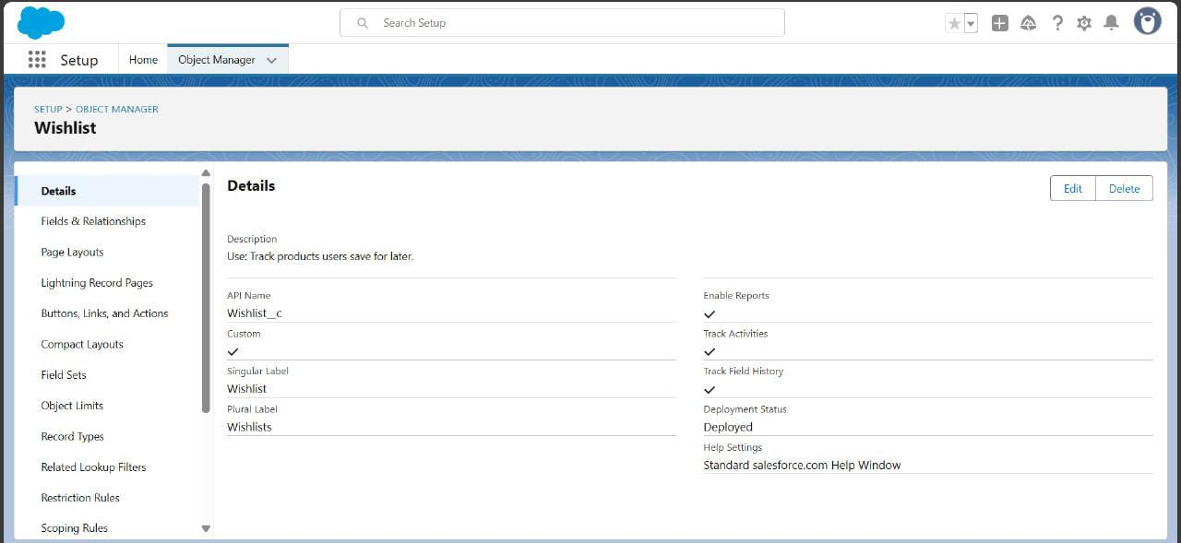

* **Feedback / Review**

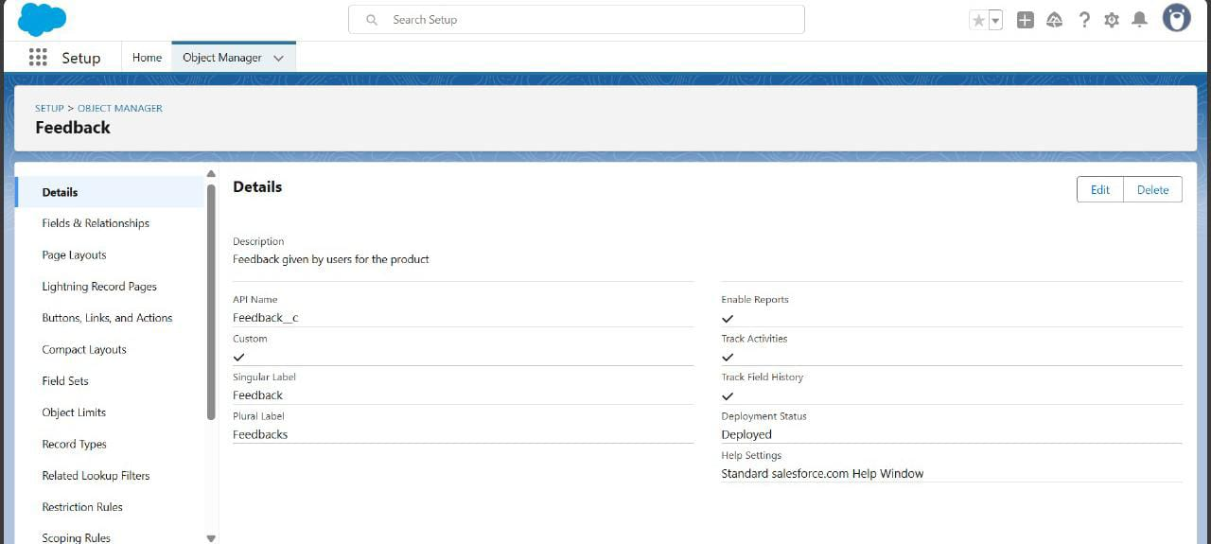

* **Shipment (Standard)**

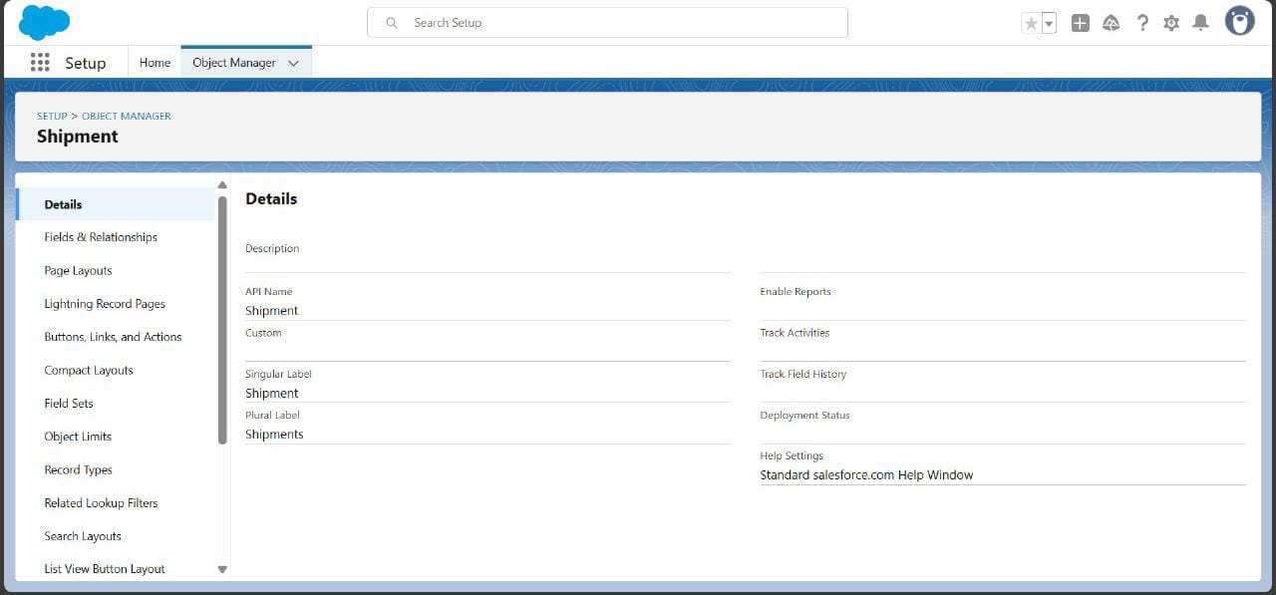

* **Return Request**

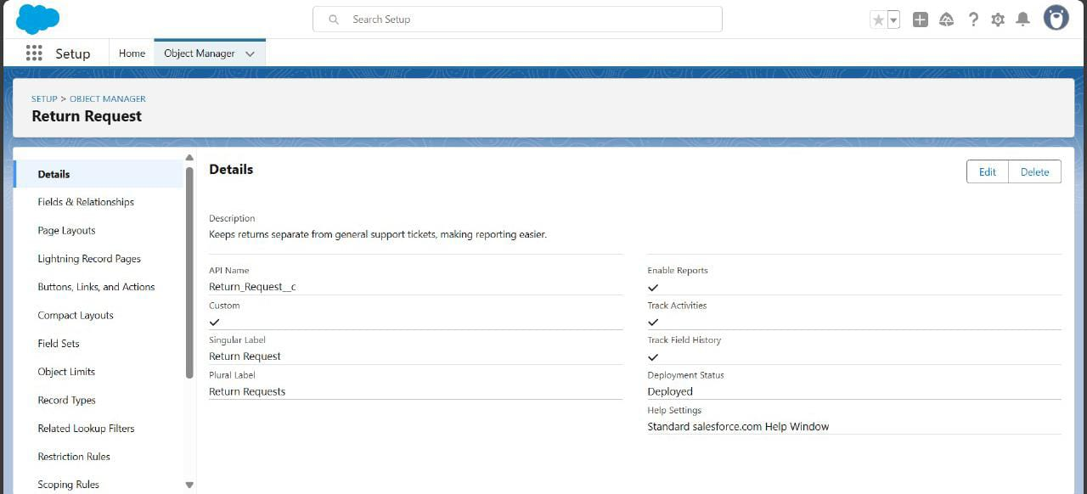

**2.Fields**

* **Wishlist**

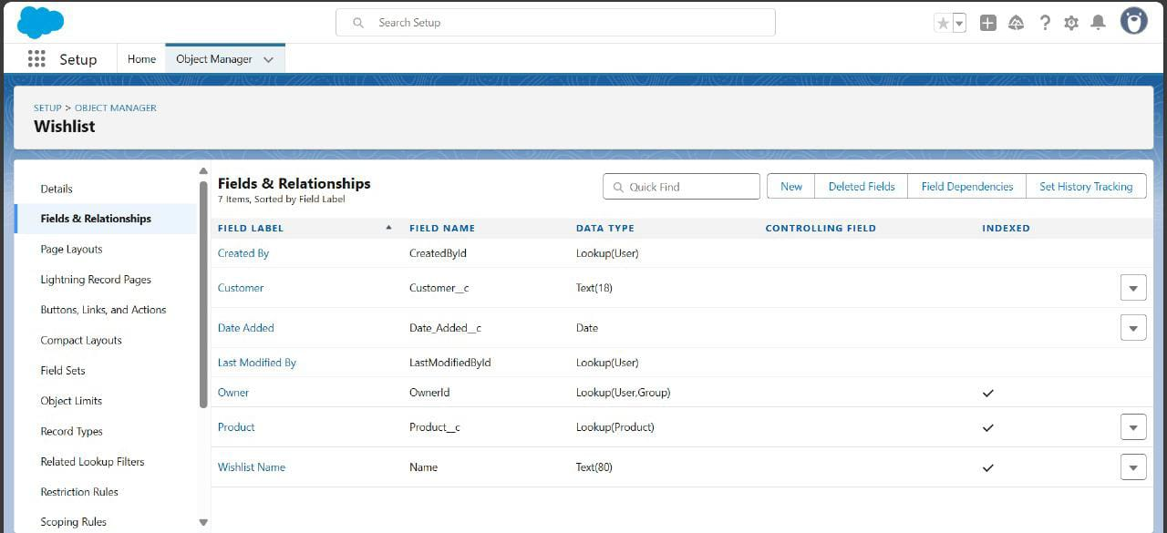

* **Shipment**

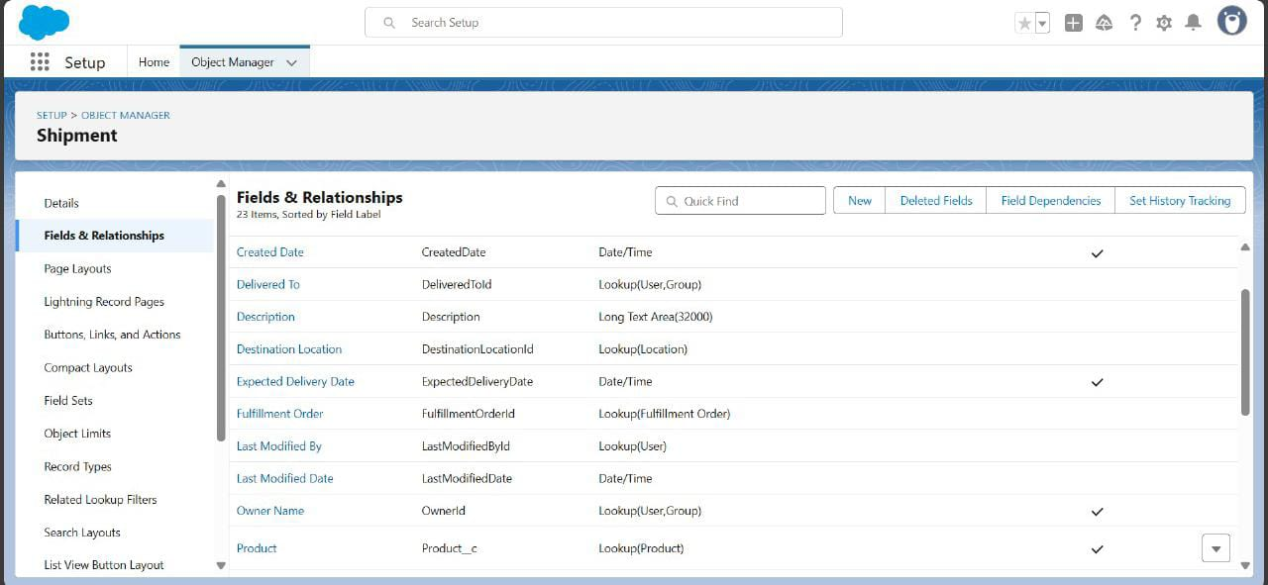

* **Feedback**



* **Return Request**

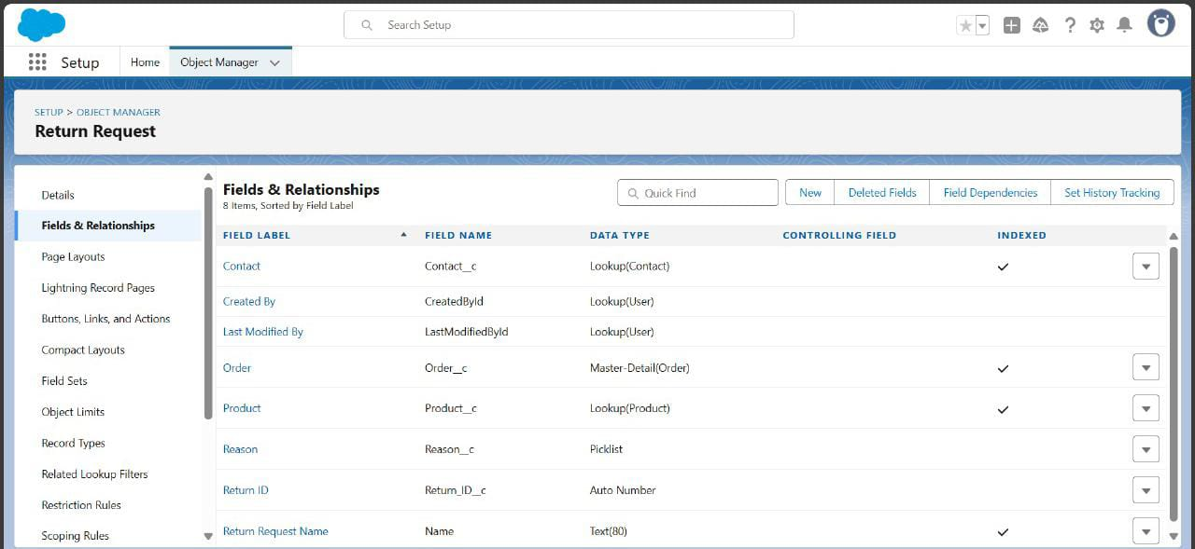

**•**

**3. Record Types.**

* **Order Record Types**

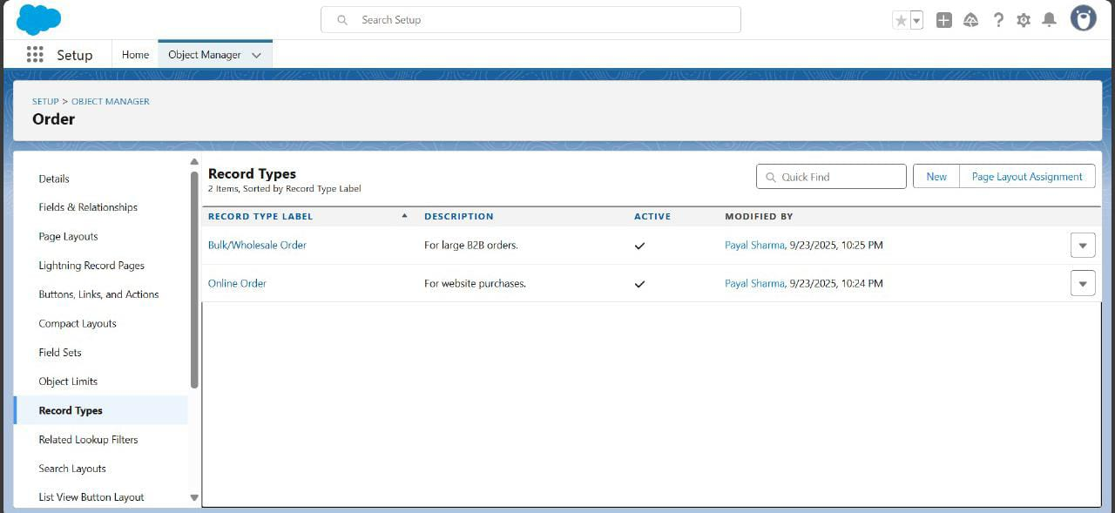

* + **Online Order** → For website purchases.
  + **Bulk/Wholesale Order** → For large B2B orders.
* **Feedback Record Types**

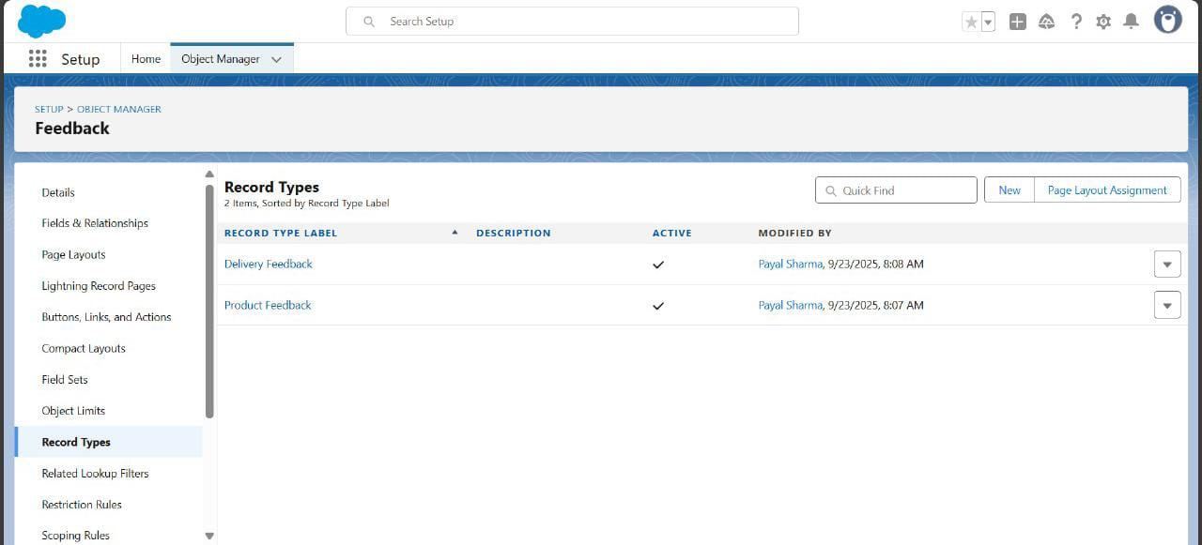

* + **Product Feedback** → Ratings & reviews for items.
  + **Delivery Feedback** → Ratings for shipment experience.

**4 Page Layouts**

* **Product Layout** → Show fields like Product Name, Price, Stock, Vendor.
* **Order Layout** → Customer, Product, Quantity, Delivery Status.
* **Feedback Layout** → Customer, Rating, Comments, Related Order.
* **Return Request Layout** → Order, Product, Reason, Status.

**5 .Compact Layouts**

• **Product** → Product Name, Price, Stock Status.

• **Order** → Order Number, Customer, Status, Delivery Date.

• **Feedback** → Rating, Customer, Product.

• **Return Request** → Request ID, Order, Reason, Status.

**6. Schema Builder**

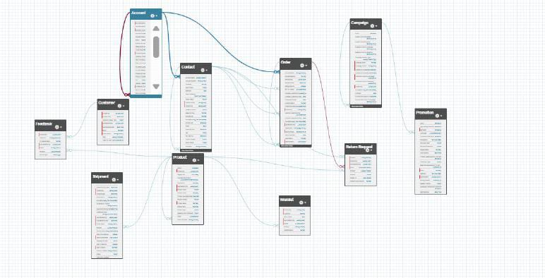

* **Accounts & Customers** separated for business vs. end-user management.
* **Products** centrally linked with Orders, Wishlists, Feedback, and Vendors.
* **Orders & Return Requests** ensure full purchase + refund lifecycle.
* **Campaigns & Promotions** support marketing and discount tracking.
* **Wishlist & Feedback** capture customer preferences and satisfaction.
* **Vendors** tied to Products for supplier management.

**7.Lookup vs Master-Detail vs Hierarchical Relationships**

| **Parent Object** | **Child Object** | **Relationship Type** | **Notes** |
| --- | --- | --- | --- |
| Account | Customer | Lookup | Customer linked to an Account. |
| Customer | Feedback | Lookup | Feedback submitted for a customer. |
| Product | Feedback | Lookup | Feedback tied to a specific product. |
| Customer | Order | Lookup | Order placed by a customer. |
| Order | Return Request | Master-Detail | Return cannot exist without an order. |
| Vendor | Product | Lookup | Product supplied by a vendor. |
| Product | Promotion | Junction Object | Many-to-many → a product can have multiple promotions, and promotions can apply to multiple products. |
| Campaign | Promotion | Lookup | Promotion linked to a campaign. |

**Phase 4: Process Automation (Admin)**

**1. Validation Rules**

* Shipping address cannot be blank.

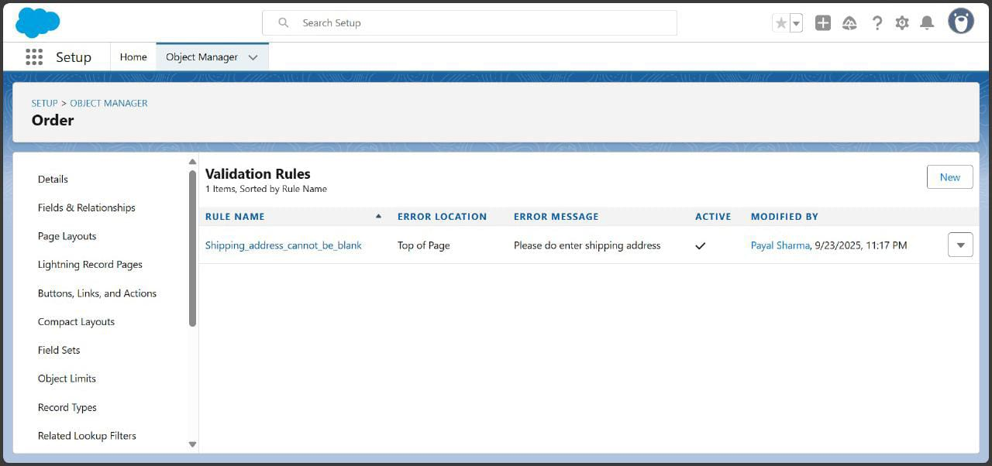

* Customer email must contain “@”.

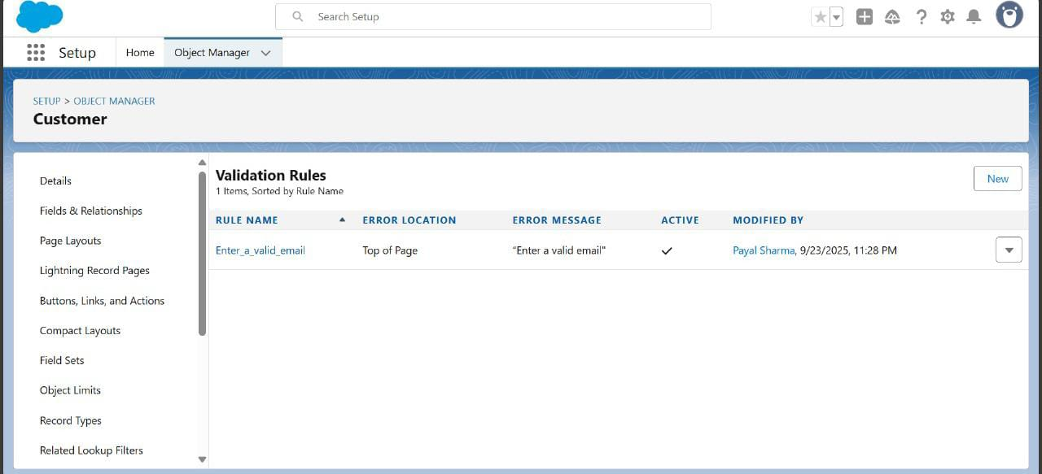

**2. Workflow Rules**

* **Order Confirmation**

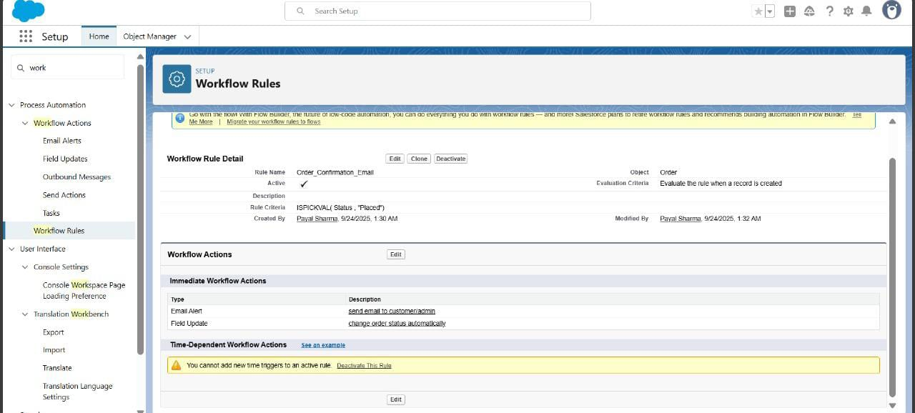

* **Objective:** Send order confirmation automatically when an order is placed.
* **Trigger:** Status = Placed (ISPICKVAL(Status__c, "Placed") for picklist)
* **Action:** Email alert to customer
* **Benefit:** Instant confirmation, reduces manual work, improves customer experience

**3. Process Builder**

* **Customer Feedback Request**
* **Objective:** Improve post-delivery engagement.
* **Trigger:** Order Status = Delivered
* **Actions:** Send automated feedback request email
* **Benefit:** Increases customer satisfaction and reviews

**4. Approval Process**

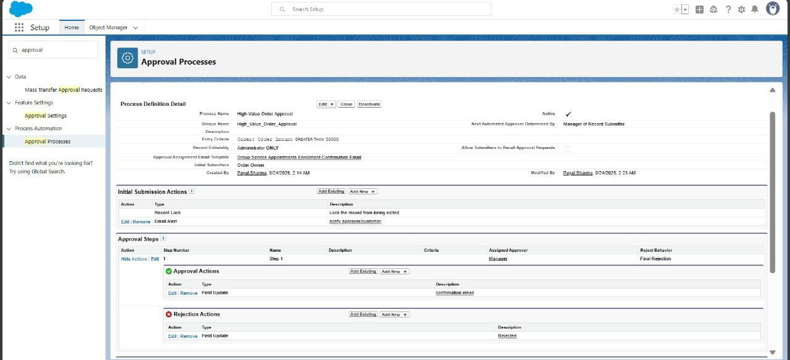

* **Objective:** Automate approval of high-value or sensitive orders.
* **Object:** Order
* **Entry Criteria:** Orders above a certain amount (e.g., $500)
* **Approver:** Manager or team lead
* **Actions:** Update status, notify approver/customer, trigger related processes
* **Benefits:** Ensures control, accountability, and reduces manual oversight

**5.Flow Builder (Screen, Record-Triggered, Scheduled, Auto-launched)**

**Customer Feedback Flow (Record-Triggered)**

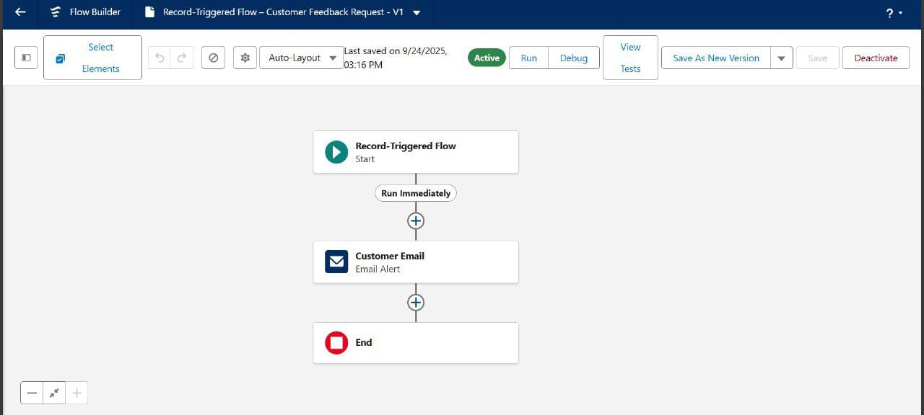

* **Objective:** Automatically send feedback request email after an order is delivered.
* **Trigger:** Record update → Status = Delivered
* **Actions:**
  + Send feedback email to customer
  + Optionally update Feedback_Sent field to TRUE
* **Benefits:** Saves manual effort, collects customer feedback automatically, improves engagement and reviews

**6. Email Alerts**

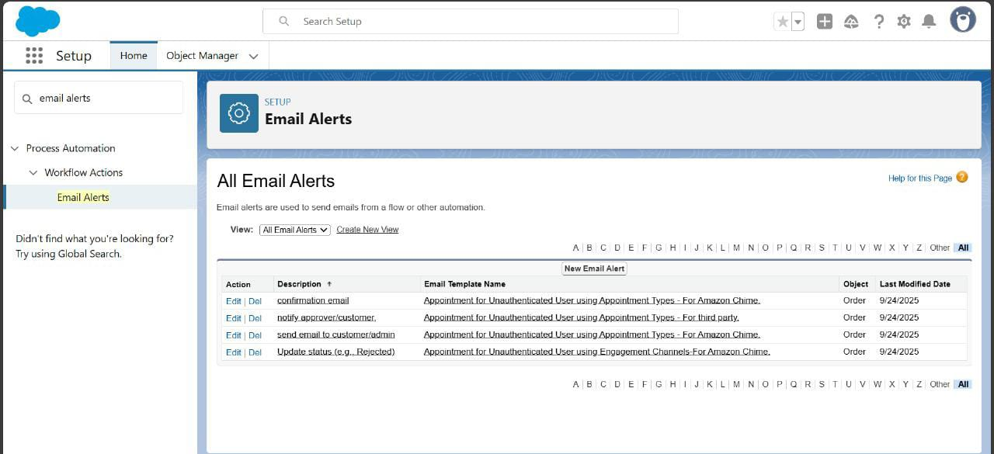

| * **Confirmation Email** → Automatically sends confirmation emails to customers after order creation, ensuring they receive immediate acknowledgment**.** * **Notify Approver/Customer** → Sends alerts to approvers/customers for required actions, supporting faster order processing and transparency. * **Customer/Admin Notification** → Configured to notify both customers and administrators regarding order updates, reducing communication gaps. * **Order Status Update (e.g., Rejected) →** Triggers automated emails when an order is rejected, keeping customers informed about their order lifecycle**.** |  |  |  |
| --- | --- | --- | --- |
|  |  |  |  |
|  |  |  |  |
|  |  |  |  |
|  |  |  |  |
|  |  |  |  |

**7. Field Updates**

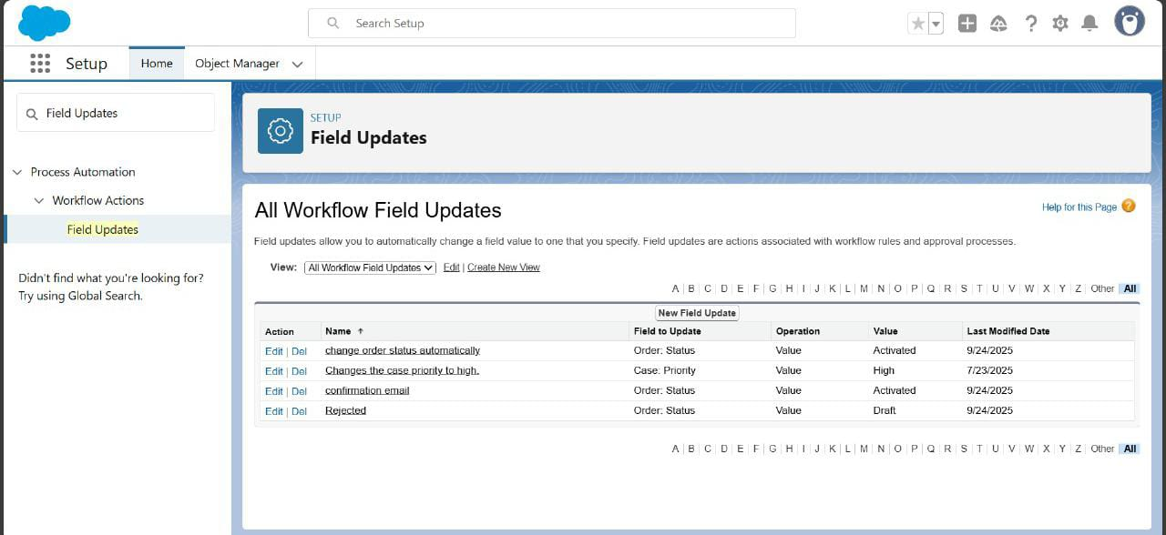

* **Order Status Automation** → Configured to automatically update the *Order Status* to *Activated* once conditions are met (streamlines order processing).
* **Case Priority Update** → Automatically sets *Case Priority* to *High* for urgent cases (improves customer support efficiency).
* **Order Confirmation Email** → Updates *Order Status* to *Activated* to trigger confirmation workflows (ensures customers receive timely updates).
* **Rejected Orders** → Workflow updates *Order Status* to *Draft/Rejected* when conditions fail (maintains clean records and prevents processing errors).

8.**Tasks**

1. Automatically assign follow-up tasks based on events like refund requests or order shipments.
2. Ensures accountability by assigning tasks to the right users or teams.
3. Reduces manual effort and improves timely action on critical processes.

**9 .Custom Notifications**

1. Sends real-time in-app alerts to users for important events (e.g., order ready, low stock).
2. Ensures immediate awareness and faster response by the relevant team.
3. Enhances operational efficiency and prevents missed actions.